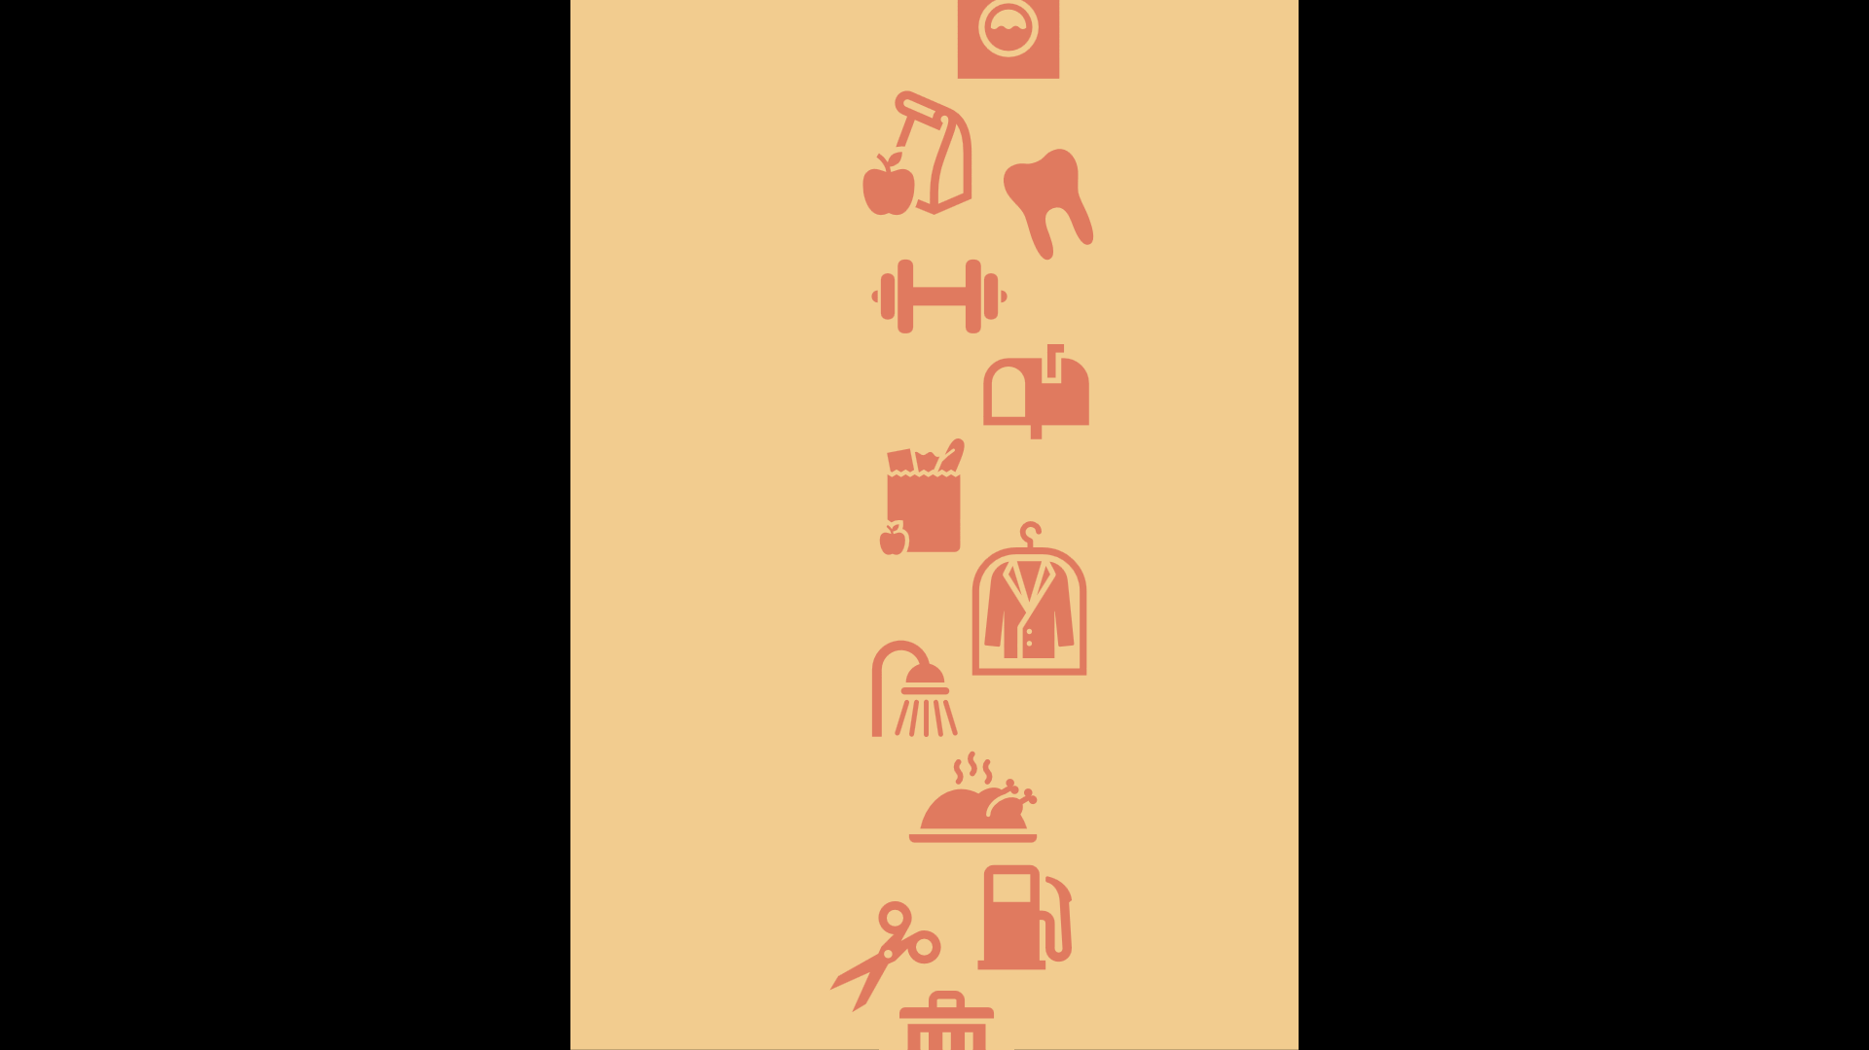
Errands
List some errands:

Salesperson
A bad salesperson wants to sell you something.
A good salesperson wants to solve a problem.

Types of customers:
Penny Pincher –
Bargain Hunter –
Impulse Buyer –
Going with your Gut –
Loyal Customer –
Need-based customer –
Wandering Customer –

